Game Design Document

Fill up the following document

1. Write the title of your project.

Ans- Dig Deeper

1. What is the goal of the game?

Ans- Find Professor Bhatcharje and the potion.

1. Write a brief story of your game.

Ans- Professor Bhatcharjee who is world famous scientist creates a potion which can make a person invisible and breathe in water. An evil scientist tries to take that so that he can sell it to the terrorist and make money.

So to protect the potion Professor Bhatcharjee drinks it and jumps in the sea. While he jumped his robot fish falls in the water and after 2 hours get activated. Its job is to find the Professor. It started finding the Professor. The evil scientist sends his robot shark behind the fish so that they can also get to the professor. Help the fish find the professor by playing the game. Good luck !!

1. Which are the playing characters of this game?

* Playing characters are the ones who respond to the user based on the input from the user.
* Cars, monkeys, dinos, wizards, etc., are the playing characters in the game.

|  |  |  |
| --- | --- | --- |
| Number | Character Name | What can this character do? |
| 1. | Fish | It can move up and down |
|  |  |  |
|  |  |  |

1. Which are the Non-Playing Characters of this game?

* Non-Playing characters are the ones that don't have an action or behavior when the user interacts with the game.
* Hurdles, stones, bananas, coins, etc., are non-playing characters in the game.

|  |  |  |
| --- | --- | --- |
| Number | Character Name | What can this character do? |
| 1 | Shark | Follows the fish |
| 2 | Heart | Gives an extra life to the fish |
| 3 | Shield | Protects the fish but gets deactivated after hitting an obstacle |
| 5 | Chest | It gives 100 coins |
| 6 | Anchor, Mast, Bottle, Plastic bag, Broken Barrel, Barrel, Net, Seaweed, Steering Wheel, 3 types of Stones | Obstacles |

Draw your imagination of this game. What does this game look like?

* Draw the game either on your computer or on paper.
* Add images of the game scenes to show each of the playing and non-playing characters at least once.

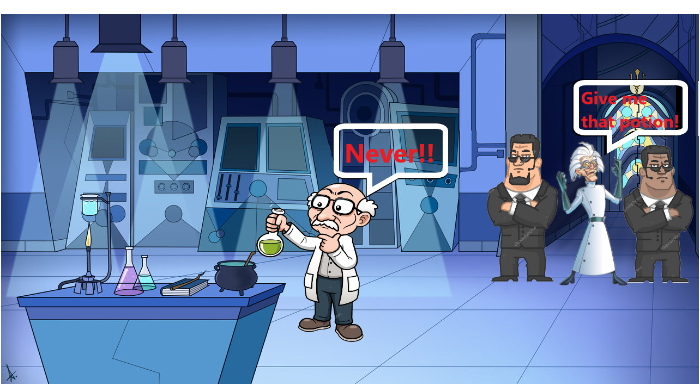

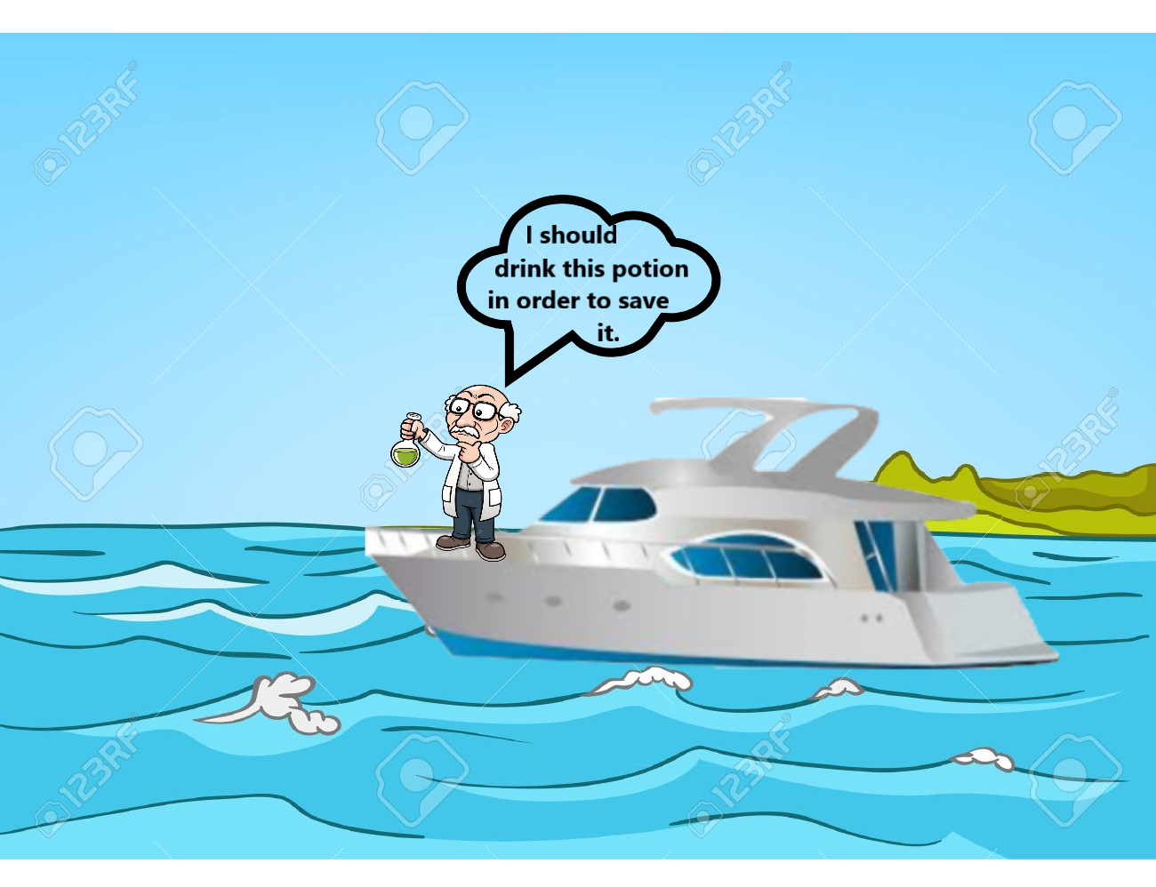

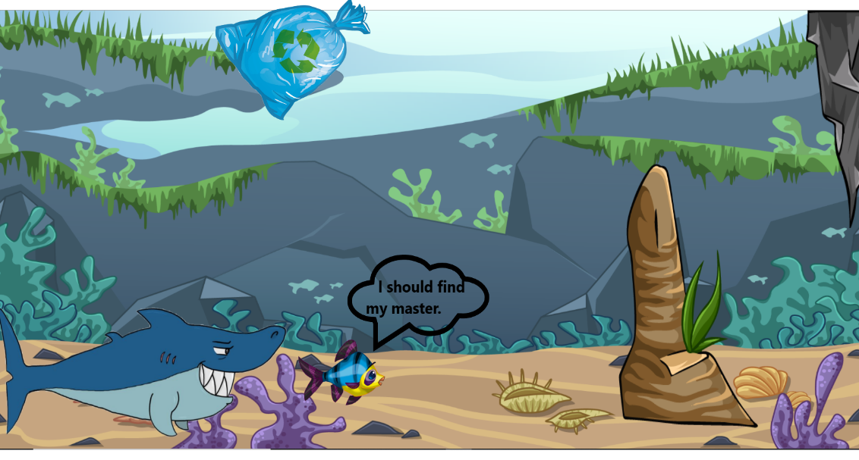

How do you plan to make your game engaging?

Ans- By adding different obstacles, giving chest full of coins, giving extra lives, by adding different backgrounds.